South League 2023
Sponsored by:
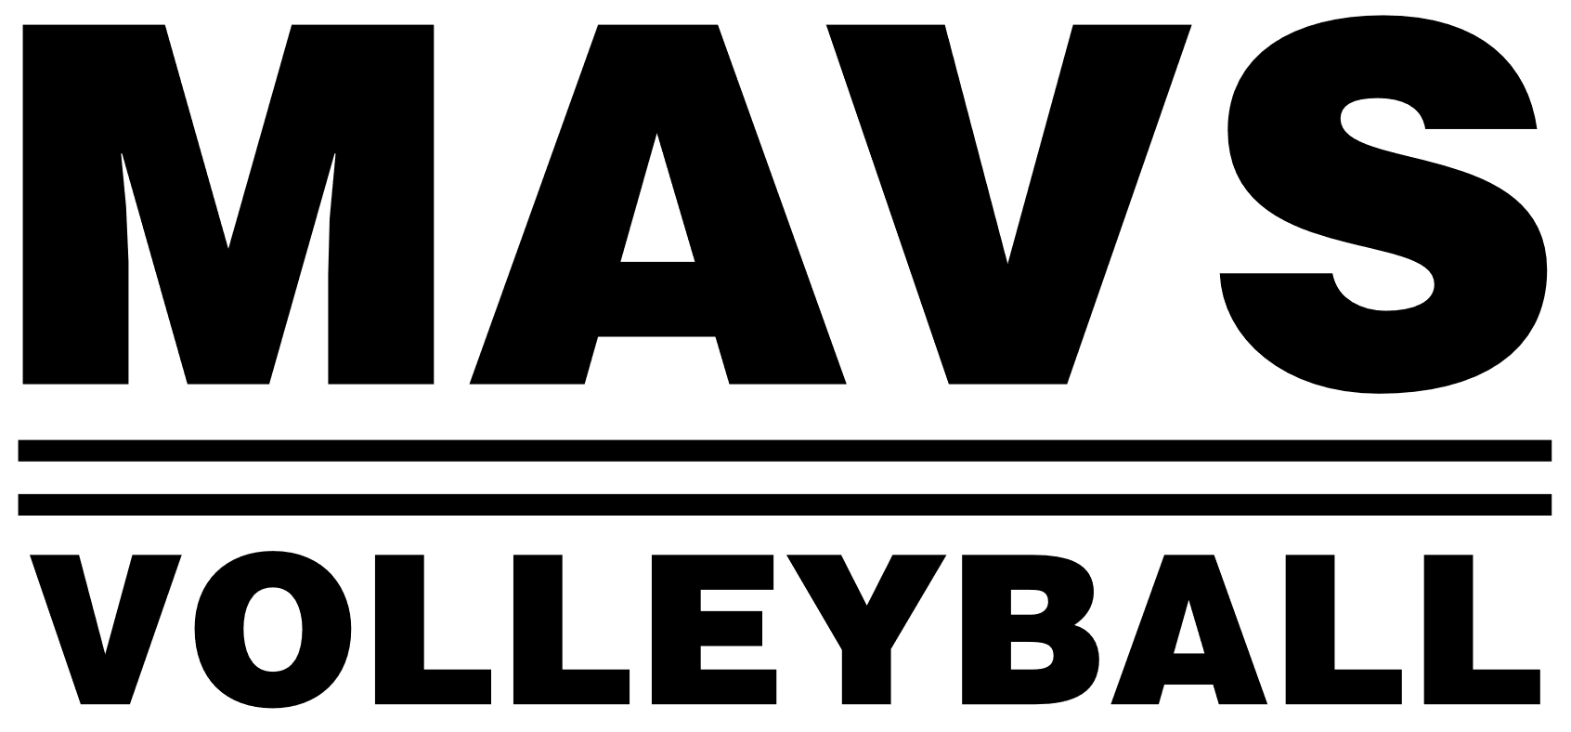

Rules and Guidelines for Match Play

- Coaching/Supervision
  - Teams are not required to have a coach; however, an adult must always supervise the bench.
  - Team rosters shall be submitted prior to competing in the team’s first match.

- Play
  - Warm-up periods shall be three minutes. Both teams shall share the court for hitting purposes and shall call out attacks to avoid both sides attacking the same zone at the same time. MAVS does NOT provide warm-up balls.
  - The first team to reach 25 points, beginning at 0-0, with a two-point margin will win the first set. The first team to reach 25 points, beginning at 0-0, with a two-point margin shall win the second set OR the team with a one-point advantage when time has expired. Officials will do their best to announce time remaining.
  - All matches are two sets only.
  - Substitutions shall occur without formal request or delay but must follow normal procedures. Players may occupy one service order position only.
  - One 30-second timeout is granted per team per set.
  - Forfeit time is 5 minutes past the scheduled start time for the first set; 25 minutes past the scheduled start time for the second set. Some lenience will be allowed due to traffic.

- Team make-up
  - Teams must have a minimum of 5 players to compete; either to begin a match or continue playing after an injury. Teams with fewer than 5 eligible players shall forfeit all sets until 5 eligible players can be obtained.
  - Teams with 5 players must fill a “ghost” position. When the “ghost” player rotates to occupy position 1, the team will lose that rally. When the “ghost” player occupies a front row position, the team will be required to play with only two players in front row positions.
  - If a team is unable to compete due to not enough players, the complete team may provide players sufficient to allow the incomplete team to compete, but the incomplete team shall still forfeit the match with a score of 25-0. In this instance, the game will not be officiated.
- Players
  - Rosters must include a minimum of 8 players and a maximum of 12.
  - Individuals may be listed on more than one roster.
  - Individuals that compete for teams must be listed on the official roster of each team. “Fill-in” players are not permitted.
  - The libero must identify herself to the official prior to the start of the game. The libero may only serve in one service rotation.

- Facility
  - Each team is responsible for picking up their trash and keeping their area clean.
  - NO OUTSIDE FOOD IS ALLOWED IN FACILITY. Full concessions will be provided.

Questions, please contact Kathy Bates kbates@mavskc.com

